High-Level Design
Project 1
Load and Process IPL match data

Objective:
The project aims to analyse the Indian Premier League (IPL) cricket dataset and extract valuable insights and statistics related to player performances across multiple seasons.

Dataset Details:
- Dataset includes ball-by-ball information for every match played between 2008 and 2022 seasons.
- Tables: Match Details (IPL_Matches_2008_2022.csv), ball by ball details (IPL_Ball_by_Ball_2008_2022)

Context:
The IPL is a professional men's Twenty20 cricket league contested by ten teams based out of ten Indian cities. It is the most-attended cricket league globally and has significant economic and viewership impact.

Infrastructure Requirements:
- S3: Data storage
- Glue: Data processing and transformation

Infrastructure Setup Block Diagram:

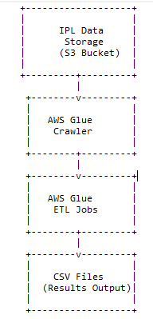

4. Requirements:
The project has multiple requirements related to IPL match data analysis. Here are the high-level descriptions of the requirements:
- Requirement No 1: Fastest Centuries
- Requirement No 2: Most Fours Innings
- Requirement No 3: Most Runs
- Requirement No 4: Most Wickets
- Requirement No 5: Most Runs Conceded In Innings
- Requirement No 6: Fastest Fifties
- Requirement No 7: Most Sixes Innings

High Level Workflow:
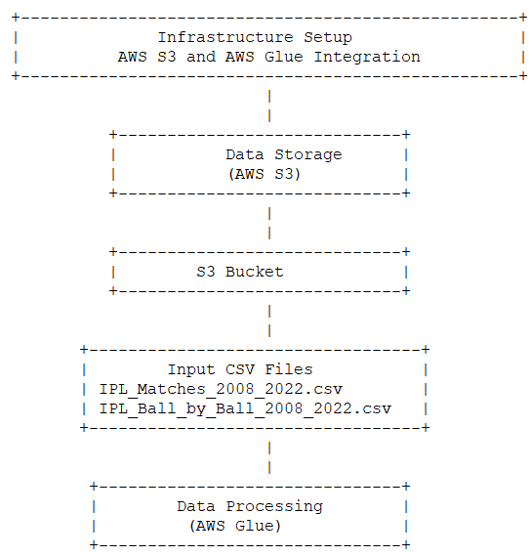
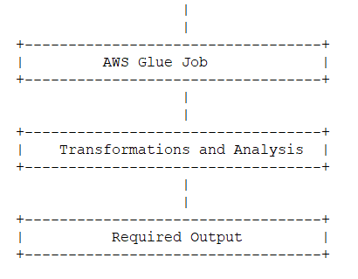

High-Level Description:

- Set up AWS Glue crawler to discover and catalogue the dataset files in the S3 bucket.
- Create separate Glue ETL jobs for each requirement to extract relevant data from the dataset tables.
- Perform data transformations and aggregations to calculate the desired statistics.
- Sort the results based on the specified criteria (e.g., runs scored, balls faced, wickets taken).
- Write the final results to separate CSV files for each season, following the specified naming convention.

Benefits:
- Efficient data processing and transformation using AWS Glue.
- Scalability and handling of large datasets.
- Durability, availability, and scalability of data storage using S3.

The IPL Data Processing Project enables the extraction of valuable insights and records from the IPL dataset, providing stakeholders with a deeper understanding of player performances and facilitating further analysis and presentation.

